**UCL Summer School Coursework Coversheet**

Complete and paste this coversheet to the front of your assignment

|  |
| --- |
| **Student candidate number:** KSRN1 |
| **Programme**: UCL Summer School |
| **Module:** ISSU0098: Data Driven Web-Based Applications |
| **Assignment Title**: Individual Coding Assignment |
| **Word Count**:  (Excluding abstract, footnotes, bibliography/references list, appendices, tables, figures and title) |

**Student Declaration:**

By submitting this assessment, I confirm that all the work is my own unless collaboration has been specifically authorised. I understand that any form of [Academic Misconduct](https://www.ucl.ac.uk/students/exams-and-assessments/academic-integrity) is strictly prohibited, including the use of essay mills, homework help sites, plagiarism (including self-plagiarism), collusion, falsification, impersonation or any other action which might give me an unfair advantage.  

|  |
| --- |
| If you have used AI tools in your assignment, please provide a one sentence summary of how it was used:  I used ChatGPT only for giving guidelines of writing code and debugging for the problems I cannot solve by myself. All the rest of the code and all the essay writing are my original work. |

I am aware that my assignment may be used in anonymised form in helping future students.

**Opt-out**: do not allow material to be used in teaching future students

|  |
| --- |
| **Extenuating Circumstances**    Please only complete this section if you have applied for EXTENUATING CIRCUMSTANCES (EC)  *Please tick the relevant box*:   * I have applied for EC but have NOT received a decision from the panel yet * I have applied for EC and have received a decision from the panel.   **My new deadline is:** Click or tap to enter a date.  *Please note that after the original deadline whatever you submit will be deposited on Turnitin so you cannot submit multiple times. If you want to check your Turnitin score before you submit you can do this by uploading a ‘test’ submission on the following Moodle page:*  [*https://moodle.ucl.ac.uk/enrol/index.php?id=34*](https://moodle.ucl.ac.uk/enrol/index.php?id=34) |

**Introduction**

In this report I will use the code and the screenshots to show how I tried to improve the given registration website.

When beautifying the website, I mainly used CSS to style each element in the webpages and I deleted the useless elements on the website.

I not only tried to improve the looking of the website, but also improved the functions of the website such as including more entities in the database and adding useful instructions in the webpages. These new features can be done by using jQuery and SQL together with PHP and HTML.

I did not change any entity or attributes in the database system so the .sql file is not included in this submission.

This report is written by Xuan Lin, Student Number: 24238014.

**Improving the website: beautifying**

I will show the code for beautifying all of the web pages first as the styling of the pages uses the same CSS code and demonstrate how I make changes to each web page separately.

**Repeated code for beautifying**

As I want to keep the styling to be the same among all the web pages, I used the same CSS code to style all the web pages. It includes adding the styling to the buttons, changing the style of the table and adding the background image to the website. The code example provided in W3Schools is helpful and they are good references.[1] The hover selector tutorial in W3Wschools also inspired me about designing the buttons.[2]:

/*css for registration pages*/

body

{

background-image:url('../images/uk_image.png');

background-size: cover;

}

table{

background-color: rgb(255, 238, 255);

opacity: 0.8;

font-family:system-ui, -apple-system, BlinkMacSystemFont, 'Segoe UI', Roboto, Oxygen, Ubuntu, Cantarell, 'Open Sans', 'Helvetica Neue', sans-serif;

}

#navBack {

background-color: rgb(180, 75, 180);

border: none;

color: white;

padding: 15px 15px;

display: inline-block;

font-size: 16px;

margin: 2px 1px;

cursor: pointer;

border-radius: 12px;

transition-duration: 0.4s;

}

#navBack:hover {

background-color: purple;

color: white;

}

#header {

text-align: center;

font-size: 30px;

font-family:system-ui, -apple-system, BlinkMacSystemFont, 'Segoe UI', Roboto, Oxygen, Ubuntu, Cantarell, 'Open Sans', 'Helvetica Neue', sans-serif;

padding: 10px;

color: white;

background-color: rgb(180, 75, 180);

}

#information{

background-color: rgb(180, 75, 180);

}

#next_button{

background-color: rgb(180, 75, 180);

border: none;

color: white;

padding: 15px 15px;

text-align: center;

text-decoration: none;

display: inline-block;

font-size: 16px;

margin: 2px 1px;

cursor: pointer;

border-radius: 12px;

transition-duration: 0.4s;

}

#next_button:hover {

background-color: purple;

color: white;

}

#footer {

position: fixed;

bottom: 0;

left: 0;

width: 100%;

background-color: rgba(180, 75, 180);

color: white;

padding: 10px;

text-align: left;

}

**Home Page**

For the home page, I delated the second row of the table and the ‘click here’ box in order to make the webpage cleaner. I redesigned the table structure and added styling to the body, table, ‘register your details’ button, header, ‘registered user list’ button, and footer. In addition, I added accordion to the home page by using the function provided in jQuery.[3]

The CSS code below is used for beautifying this webpage by making use of jQuery:

/* css for Home Page*/

#accordion{

font-family:system-ui, -apple-system, BlinkMacSystemFont, 'Segoe UI', Roboto, Oxygen, Ubuntu, Cantarell, 'Open Sans', 'Helvetica Neue', sans-serif;

}

#navList {

background-color: rgb(180, 75, 180);

border: none;

color: white;

padding: 15px 15px;

text-decoration: none;

display: inline-block;

font-size: 16px;

margin: 2px 1px;

cursor: pointer;

border-radius: 12px;

transition-duration: 0.4s;

}

#navList:hover {

background-color: purple;

color: white;

}

#accordion_title{

background-color:rgb(199, 129, 199);

}

#accordion_text{

background-color:rgb(231, 201, 231);

}

Before:

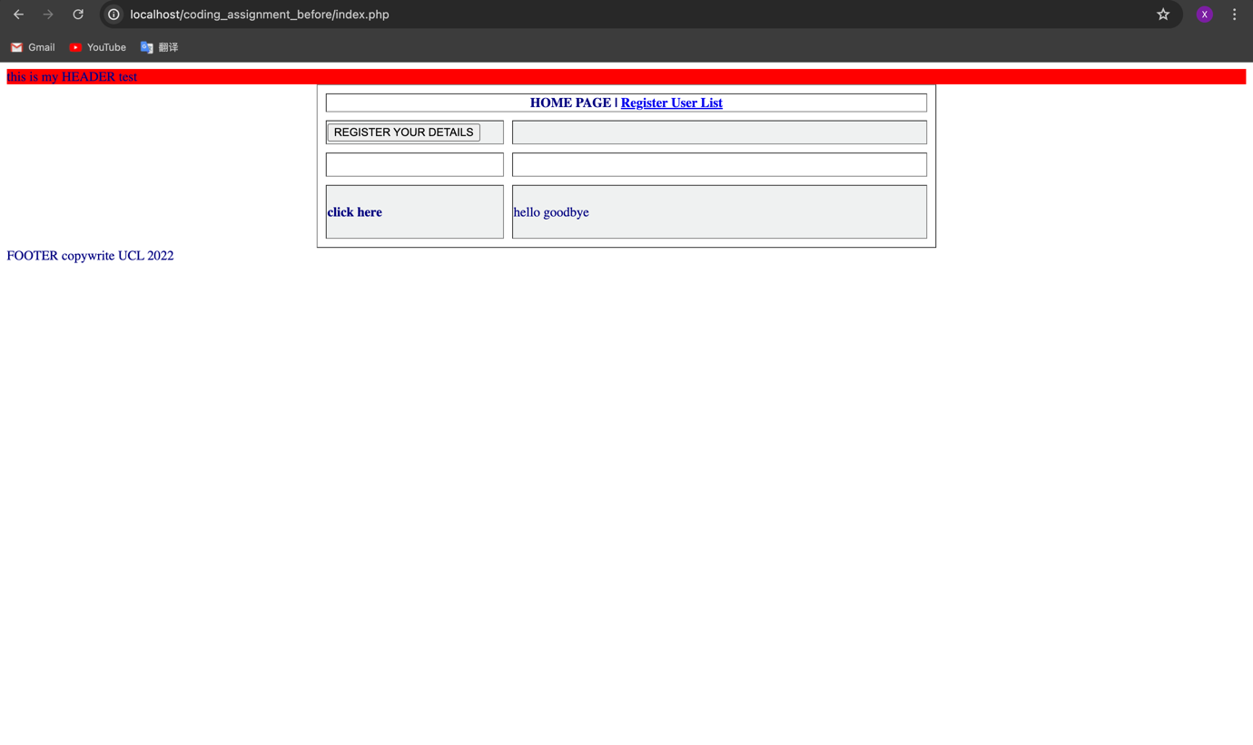

Figure 1 the home page before beautifying

After:

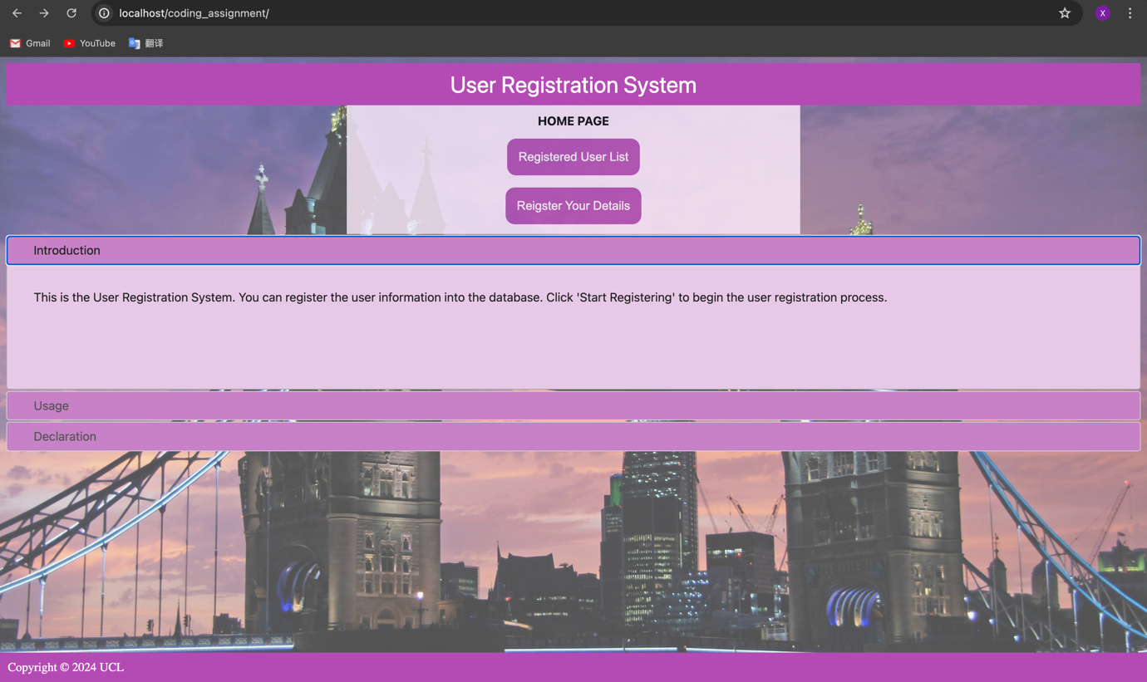

Figure 2 the home page after beautifying.

**Registration Page 1**

For the first registration page, I added the background image same as the home page and added the styling as the home page to the body, table, ‘navback’ button, header, ‘next_address’ button, and footer. In addition, I also added the feature that only when all the boxes are filled with data, the ‘next address’ button will appear on the webpage.

The code below shows how I achieved the hiding button feature:

<script>

function checkInputs() {

var f_nameCheck = $('#firstName').val();

var l_nameCheck = $('#lastName').val();

var dob = $('#newdate').val();

var age = $('#age').val();

if ((f_nameCheck === "" )|| (l_nameCheck === "") || (dob === "" )) {

$('#next_button').hide();

} else {

$('#next_button').show();

}

}

//the 3 lines below are written by the guidelines given by charGPT

//I fully understand that in the code a event listener is attached and it is called every time any input field's value changes.

$(document).ready(function() {

$('#next_button').hide(); // Initially hide the button

$('input').on('input', checkInputs); // Attach the event listener

});

</script>

Before:

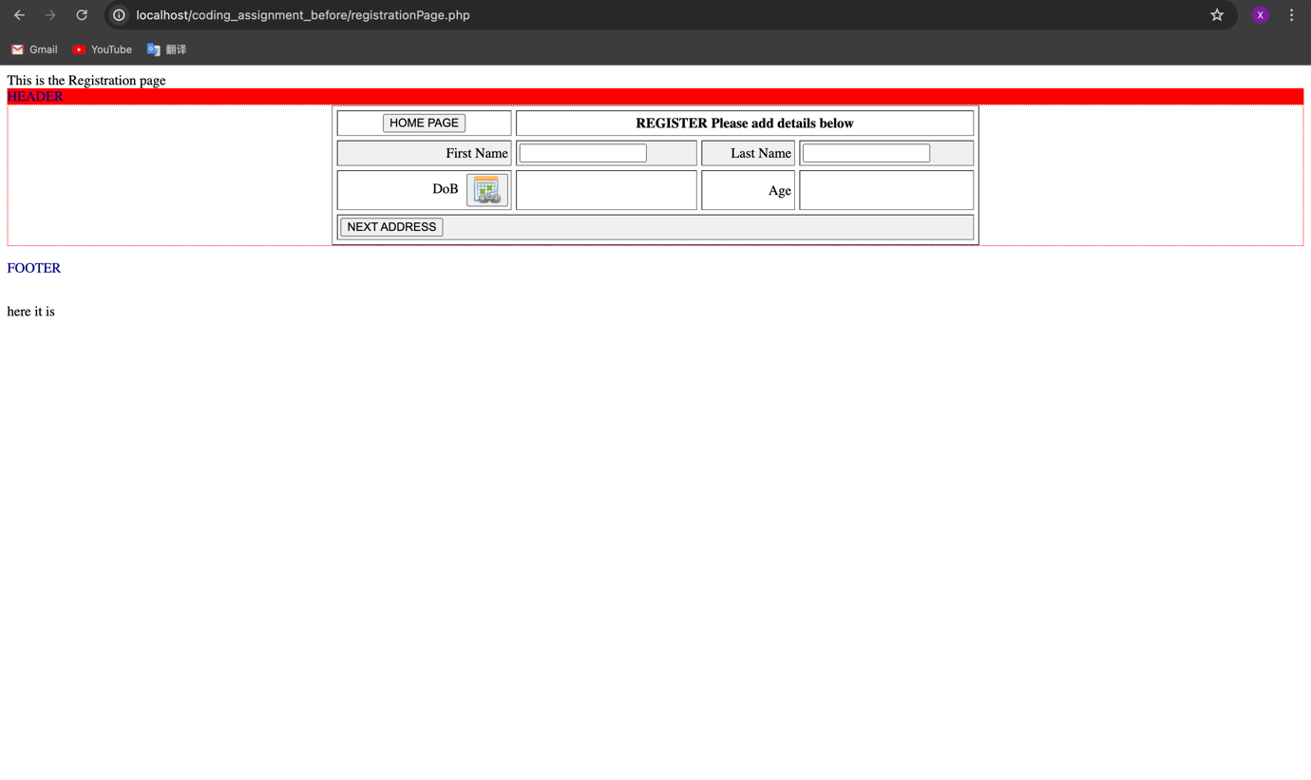

Figure 3 the first registration page before beautifying.

After:

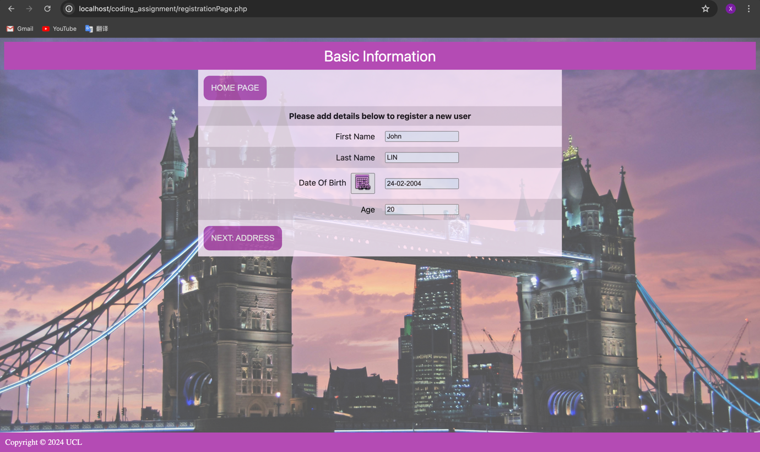

Figure 4 the first registration page after beautifying.

**Registration Page 2**

For the second registration page, I added the same styling as the previous pages to all the elements in the webpage. I hided the ‘user_id’ box and added the hiding ‘finished’ button when the slots are not fully filled.

A similar hiding button feature is achieved by the following code:

<script>

$('#user_id').hide();

function checkInputs() {

var house_numberName = $('#house_numberName').val();

var street_name = $('#street_name').val();

var city = $('#city').val();

var postcode = $('#postCode').val();

var email = $('#email').val();

var telephone = $('#telephone').val();

var feePaid = $('#feePaid').val();

var paidDate = $('#newdatePaid').val();

var dueDate = $('#newdueDate').val();

if ((house_numberName === "" )|| (street_name === "") || (city === "" )|| (postcode === "")

|| (email === "") || (telephone === "") || (feePaid === "") || (paidDate === "") || (dueDate === "")) {

$('#next_button').hide();

} else {

$('#next_button').show();

}

}

//the 3 lines below are written by the guidelines given by charGPT

//I fully understand that in the code a event listener is attached and it is called every time any input field's value changes.

$(document).ready(function() {

$('#next_button').hide();

$('input').on('input', checkInputs);

});

</script>

Before:

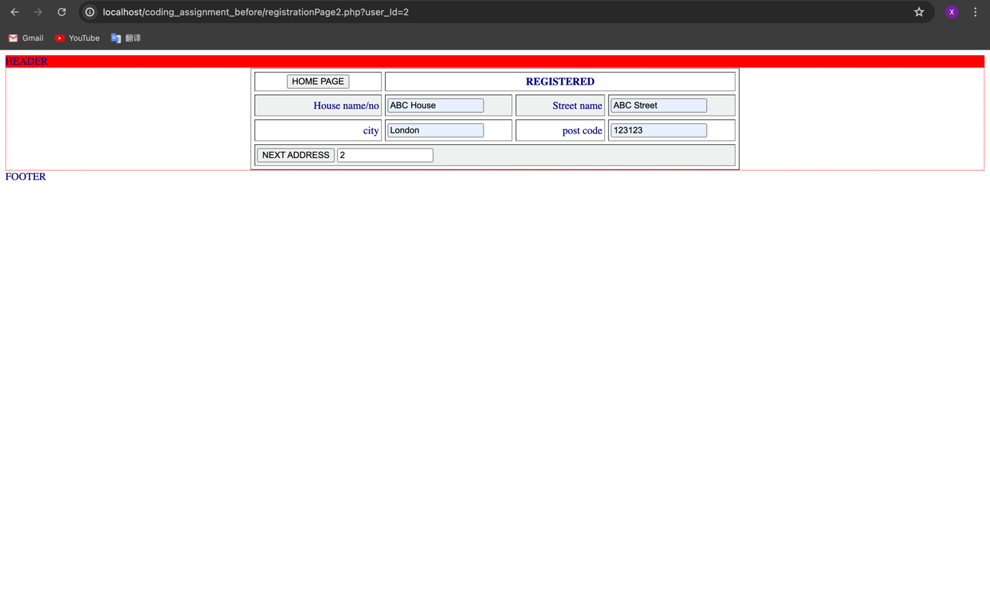

Figure 5 the second registration page before beautifying.

After:

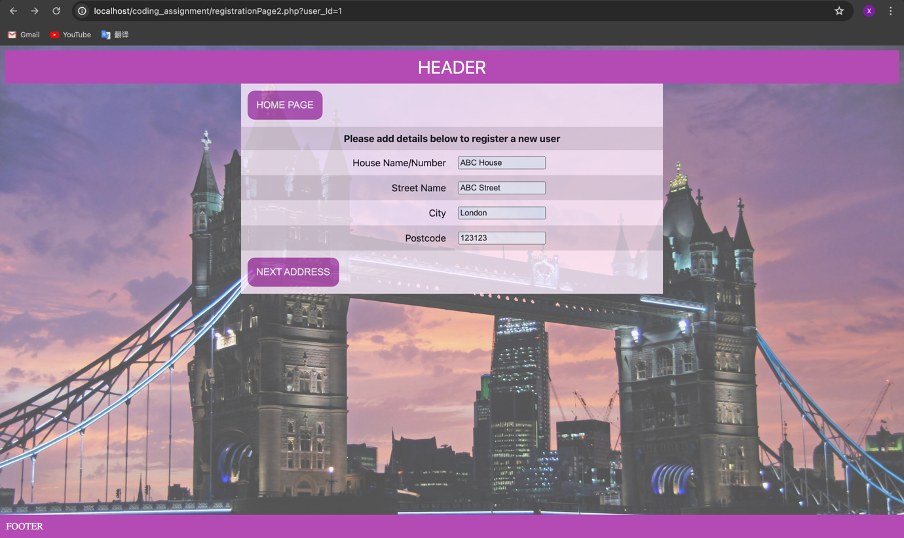

Figure 6 the second registration page after beautifying.

**Registration Success Page**

For the registration success page. I added the same styling as the previous pages and made some changes to the colour of the table. I also changed the ‘HOME’ and ‘empty database’ boxes into buttons.

The change of colour of the table is achieved by the following code:

$("tr:odd").css({"background-color": "rgb(180, 75, 180)", "color": "rgb(255, 238, 255)"});

The change of ‘HOME’ and ‘empty database’ boxes into buttons is achieved by the following code:

<table border="0" align="center" cellpadding="4" cellspacing="4">

<tbody>

<tr>

<td width="60.7%"><button id="homeLink">HOME</button></td>

<td ><button id="truncate">Empty Database</button></td>

</tr>

</tbody>

</table>

Before:

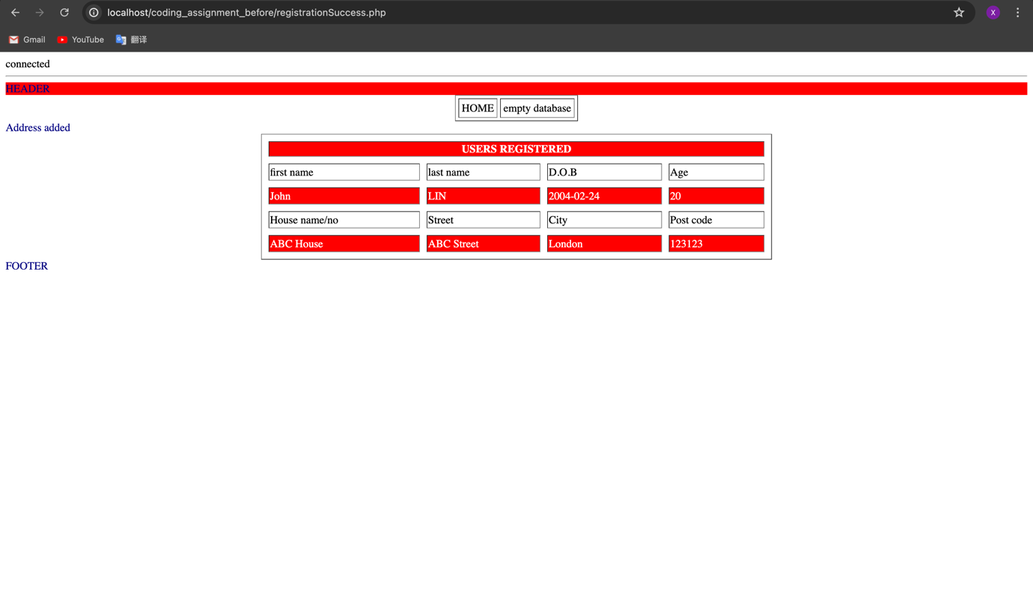

Figure 7 the registration success page before beautifying.

After:

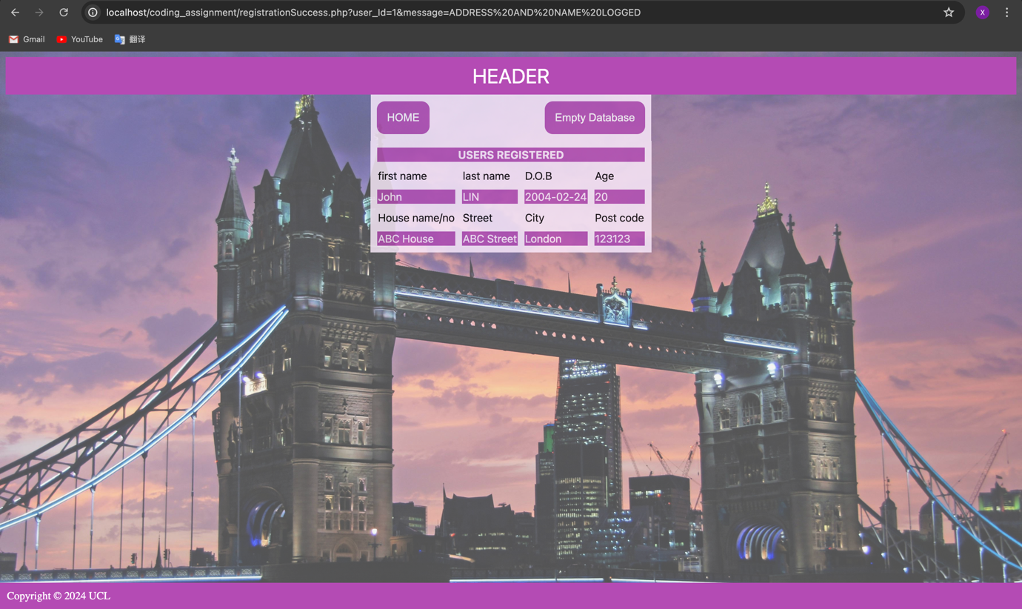

Figure 8 the registration success page after beautifying.

**Improving the website: adding new features**

Apart from the hiding button feature and the accordion I mentioned in the previous pages, a major new feature of the new website is that I have included more tables in the database on the website right now. The ‘fees’ table and the ‘contactdetails’ table are now included. Now more data like the email and the fee paid can be entered in the second registration page, which will make the registration success page also become different than before.

I took some time to understand the use of ‘left join’ in SQL and I looked up the tutorials on W3Schools and I found out this resource is quite useful for understanding SQL queries.[4]

The code below shows the changes in the uploadAddressToDB.php that make entering more data to the database become possible:

//grab postdat values for creating user row

$user_Id = $_REQUEST['user_Id'];

$house_numberName = $_REQUEST['house_numberName'];

$street_name = $_REQUEST['street_name'];

$city = $_REQUEST['city'];

$postCode = $_REQUEST['postCode'];

//new

$email = $_REQUEST['email'];

$telephone = $_REQUEST['telephone'];

$feePaid = round(floatval($_REQUEST['feePaid']), 2);

$paidDate = $_REQUEST['newdatePaid'];

$dueDate = $_REQUEST['newdueDate'];

//this is paid date

$phpdate = strtotime( $paidDate );

$mysqldate = date( 'Y-m-d', $phpdate);

//this is due date

$phpdate2 = strtotime( $dueDate );

$mysqldate2 = date( 'Y-m-d', $phpdate2);

//insert the postdata into the database

$sql1 = "INSERT INTO `address`

(`address_Id`,`user_Id`,`house_numberName`,`street_name`,`city`,`postCode`)

VALUES (NULL, '$user_Id','$house_numberName','$street_name','$city','$postCode')";

$sql2 = "INSERT INTO `contactdetails`

(`contact_Id`, `user_Id`, `email`,`telephone`)

VALUES (NULL, '$user_Id','$email','$telephone')";

$sql3 = "INSERT INTO `fees`

(`user_Id`, `feePaid`, `datePaid`, `dateDue`)

VALUES ('$user_Id', '$feePaid', '$mysqldate', '$mysqldate2')";

I have also changed the SQL query and the table layout in the registrationSuccess.php file:

//constrain the result to the user details just uploaded

//I added more entities so that more data can be displayed in the registration success page

$sql = "SELECT `firstName`, `lastName`, `dob`, `age`, `house_numberName`, `street_name`, `city`, `postCode`, `email`, `telephone`, `feePaid`, `datePaid`, `dateDue`FROM `users`

left join `address` ON `users`.`user_Id` = `address`.`user_id`

left join `contactdetails` ON `users`.`user_Id` = `contactdetails`.`user_id`

left join `fees` ON `users`.`user_Id` = `fees`.`user_id`

ORDER BY `address_Id` DESC ";

<?php

echo "<table border=\"0\" align=\"center\" cellspacing=\"10\" id=\"contactTable\">

<thead>

<tr>

<th colspan=4>USERS REGISTERED</th>

</tr>

</thead>

<tbody>";

while ($row = mysqli_fetch_array($result)){

echo

"<tr><td >first name</td><td>last name</td><td>D.O.B</td><td>Age</td></tr><tr>

<td >".$row['firstName']."</td>

<td>".$row['lastName']."</td>

<td>".$row['dob']."</td>

<td>".$row['age']."</td>

</tr>";

echo

"<tr><td>House name/no</td><td>Street</td><td>City</td><td>Post code</td></tr><tr>

<td>".$row['house_numberName']."</td>

<td>".$row['street_name']."</td>

<td>".$row['city']."</td>

<td>".$row['postCode']."</td>

</tr>";

echo

"<tr><td>Email</td><td>Telephone</td></tr><tr>

<td>".$row['email']."</td>

<td>".$row['telephone']."</td>

</tr>";

echo

"<tr><td>Paid Fee</td><td>Paid Date</td><td>Due Date</td></tr><tr>

<td>".$row['feePaid']."</td>

<td>".$row['datePaid']."</td>

<td>".$row['dateDue']."</td>

</tr>";

}

echo "</tbody></table>";

?>

After all the changes, the second page now become:

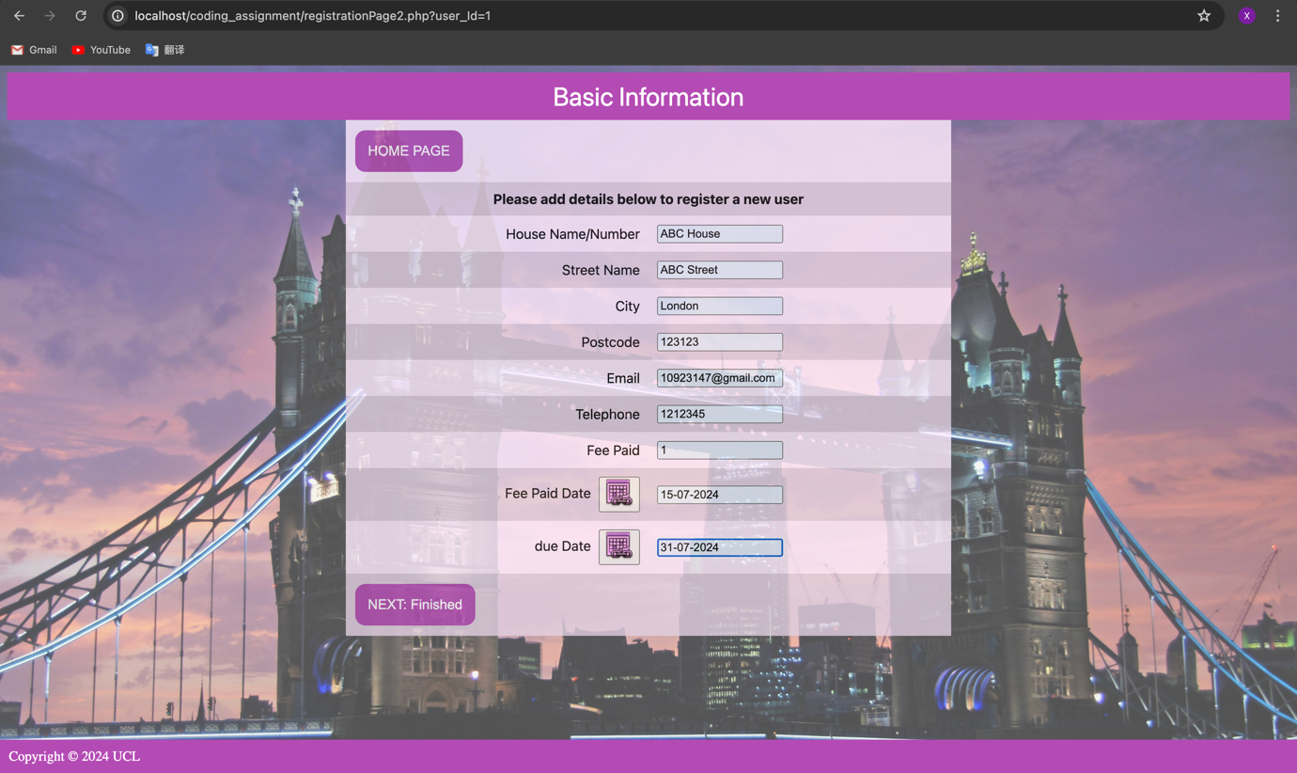

Figure 9 the final second registration page

A registration success page can now be:

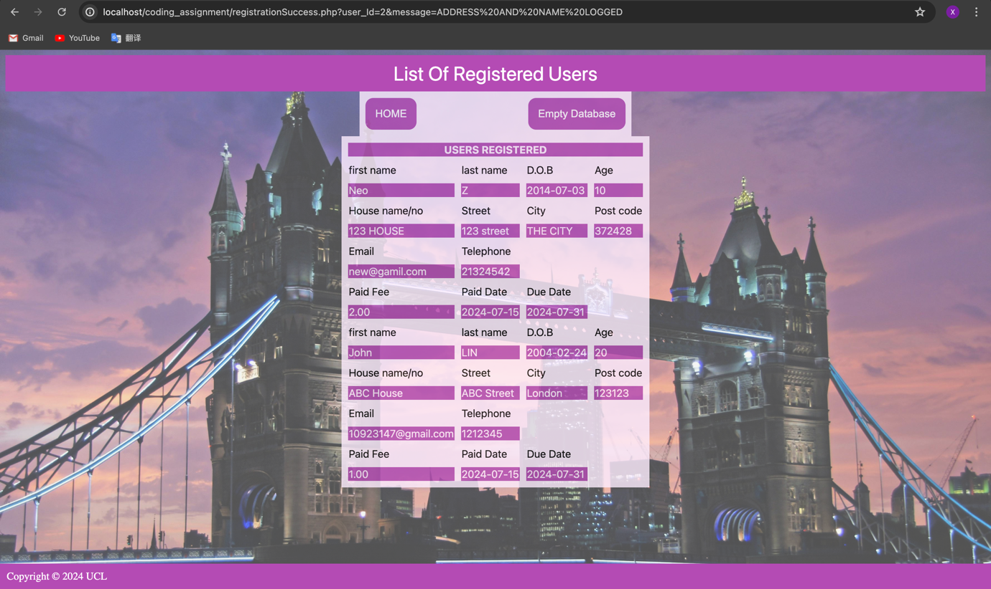

Figure 10 the final registration success page

**Conclusion**

In this project, I have mainly used CSS code for styling the elements in the web pages and made the use of SQL and jQuery to add more useful functions.

Now the website looks professional and can be used as a real registration system. I believe the improvements mentioned above can be useful for the registration system.

**Self-reflection**

By taking this module I learned how to use PHP, HTML and CSS to make web pages. I also learn how to link a website with database using phpMyAdmin and make queries using SQL. As I have learned SQL in my host university already, this module gives me a revision about it and I am feeling more confident about my understanding of database systems right now.

I am surprised that I have experienced a lot of technical issues instead of the difficulties understanding the knowledge. I learned that the practical side of learning a computer science subject is also important.

There is a lot I want to learn about making websites that are not included in this subject, such as making animations in a website. I am looking forward to making my own portfolio website and use it for finding internships and jobs in the future. Audio on the website is something that is not touched in this module as well, so I want to discover this field too.

Overall, my study journey of building website is fulfilling, and I am looking forward to continuing my computer science journey.

**References**

1. Code examples for CSS styling on W3Schools: <https://www.w3schools.com/css/css3_buttons.asp>
2. ‘hover’ selector tutorial on W3Schools: <https://www.w3schools.com/cssref/sel_hover.php>

The use of accordion in jQuery: <https://jqueryui.com/accordion/>

‘Left join’ tutorial on W3Schools: <https://www.w3schools.com/sql/sql_join_left.asp>

1. Code examples for CSS styling on W3Schools: <https://www.w3schools.com/css/css3_buttons.asp>
2. ‘hover’ selector tutorial on W3Schools: <https://www.w3schools.com/cssref/sel_hover.php>
3. The use of accordion in jQuery: <https://jqueryui.com/accordion/>
4. ‘Left join’ tutorial on W3Schools: <https://www.w3schools.com/sql/sql_join_left.asp>